**Step By Step Guide for JIRA Users**

* Installing JIRA on Your System.
* Creating Groups for JIRA
* Assigning Roles and Privileges to all Groups
* Creating projects & KEY
* Creating Issues
* Creating Components, Work Flows and scheme

_______________________________________________________________________________________________________________________________________

* **Installing on Windows Standalone**

Download JIRA from

<http://www.atlassian.com/software/jira/downloads/binary/atlassian-jira-4.3.3.exe>

1. Run setup.exe file
2. Click next to continue the installation.
3. Run Jira as a Service (Check the box)
4. Set default port as 8080 for Jira.
5. Continue the installation till finish.
6. Start JIRA server in Internet Explorer with <http://localhost:8080>

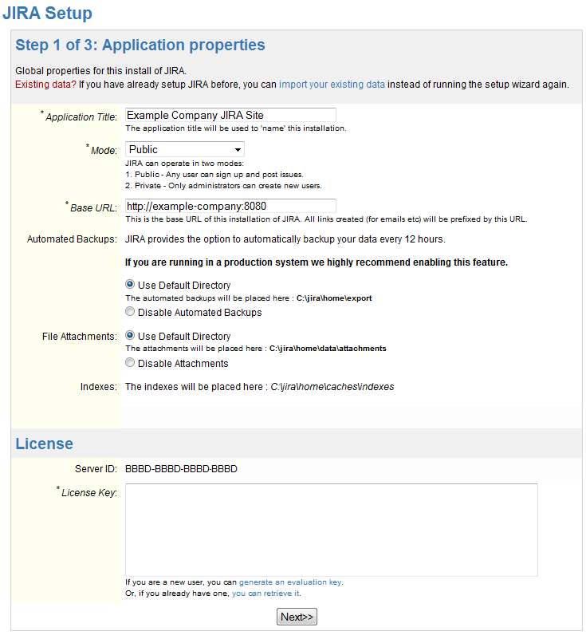

After completing the first step, we need to create Administrator Account for JIRA.

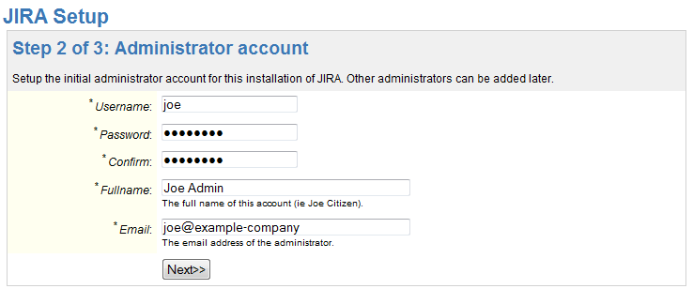

Administrator can create Other groups like, No of Admin’s, No of developers and No of Users.

After creating the Administration. Third step is Email Notification. This is an Optional. If not required we can disable the Email Notification.

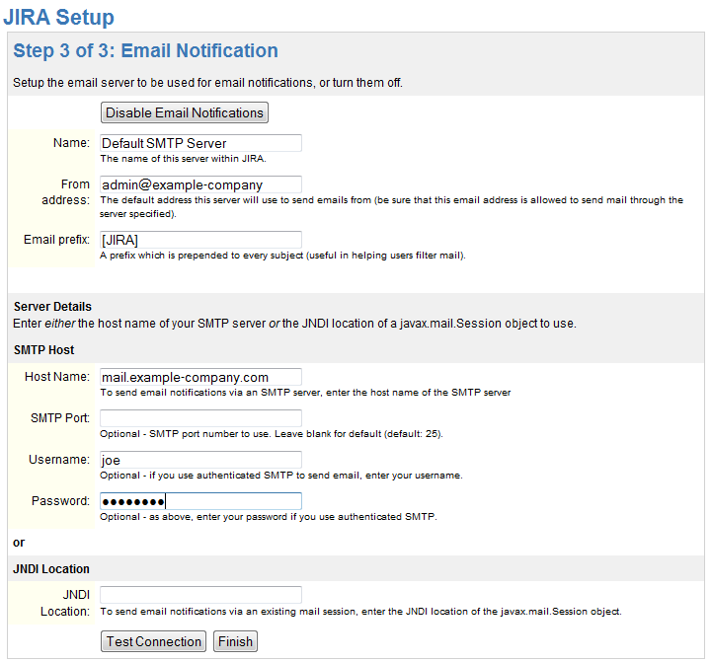

After this Installation of JIRA is completed. Now we can start Using JIRA

____________________________________________________________________________________________________________________________________________________

**Creating Groups and User for JIRA:**

* Create Administrator Log in for JIRA.
* Log In as an Administrator.
* Login as “admin” & password “admin”

**Creating New Project:**

* Click on drop down arrow on Projects Tab or shortcuts given on top of same page.
* Choose any of the following:

Task, Bug, New Feature or Improvement.

* Fill all the mandatory fields and create the Project.

**Creating New Issue:**

* Create issue by selecting Project for which you want create an issue.
* Select type of issue.
* Fill all the mandatory fields.
* Create the issue.

**Start working on Issues assigned:**

* Now Log in with Developer’s log in to solve the issue.
* Click on the project name
* It will show you all the details about issues assigned to you.
* Click on the issue on priority.
* Click on Start Progress Tab.
* Put appropriate solution in comments for the issue and resolve the issue.
* Close the issue.